Observation of the World Environment Day, 2026
Date: 05-06-2026

Bapujee College, Sarukshetri observed the World Environment Day on June, 5, 2026 with a day-long programme under the initiative of the National Service Scheme (NSS) in collaboration with the Alumni Association of the college. The basic objective of this observation was to create awareness among the mass regarding necessary measures that should be undertaken for a safe and green earth for future generation.
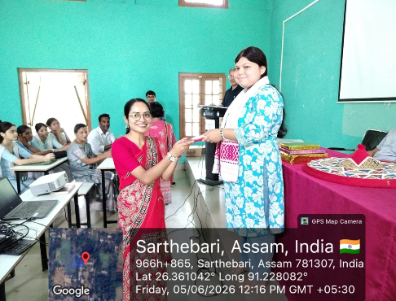
As a part of the programme, a cleanliness drive was organized at 9:00 a.m., followed by a tree plantation programme at 10:00 a.m. The activities witnessed active participation from the President and Secretary of the Alumni Association, Chittaranjan Barman and Gunajit Choudhury, respectively, along with a large number of local residents, NSS volunteers, teachers, and students of the college. At 11:00 a.m., a poster-making competition on environmental conservation was organized for the students. A lecture programme was also held, which commenced with the welcome address delivered by the Principal of the college, Dr. Khagen Das. The programme was graced by distinguished guests, including retired Principals Dr. Ramesh Das and Dr. Ananta Deka, who delivered insightful speeches highlighting the importance of environmental protection and sustainable living. A special felicitation ceremony was also organized during the event. Geetumani Deka, a student who recently secured outstanding results in the Higher Secondary Final Examination, was felicitated by the college family with a traditional gamosa, a japi, and a set of books in recognition of her academic achievement. The celebration concluded with a renewed commitment to environmental awareness, cleanliness, and social responsibility. The organizers expressed hope that such initiatives would inspire students and the community to contribute actively towards environmental conservation.
